Experiment 9
Program:
import cv2
# Step 1: Read the image
image = cv2.imread("image.jpg") # Replace with your image name
if image is None:
print("Error: Image not found!")
exit()
# Step 2: Get original dimensions
height, width = image.shape[:2]
# Step 3: Resize to Smaller Size (Half)
small_image = cv2.resize(image, (width//2, height//2))
# Step 4: Resize to Bigger Size (Double)
big_image = cv2.resize(image, (width*2, height*2))
# Step 5: Display images
cv2.imshow("Original Image", image)
cv2.imshow("Smaller Image", small_image)
cv2.imshow("Bigger Image", big_image)
cv2.waitKey(0)
cv2.destroyAllWindows()
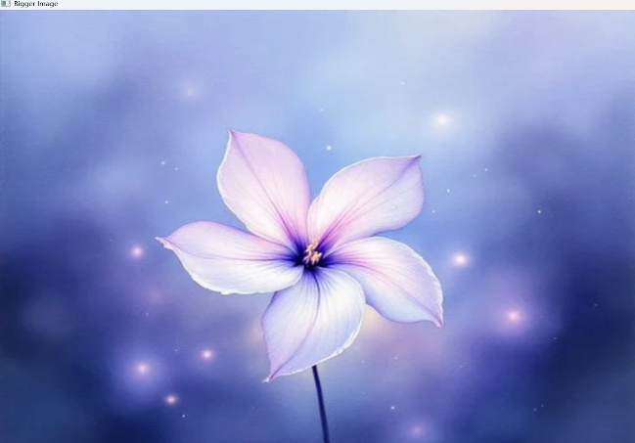
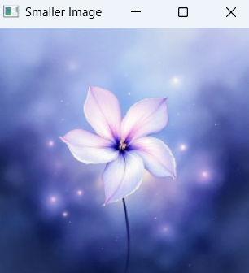
Output:

